**SHARK INTERFACE OVERVIEW**

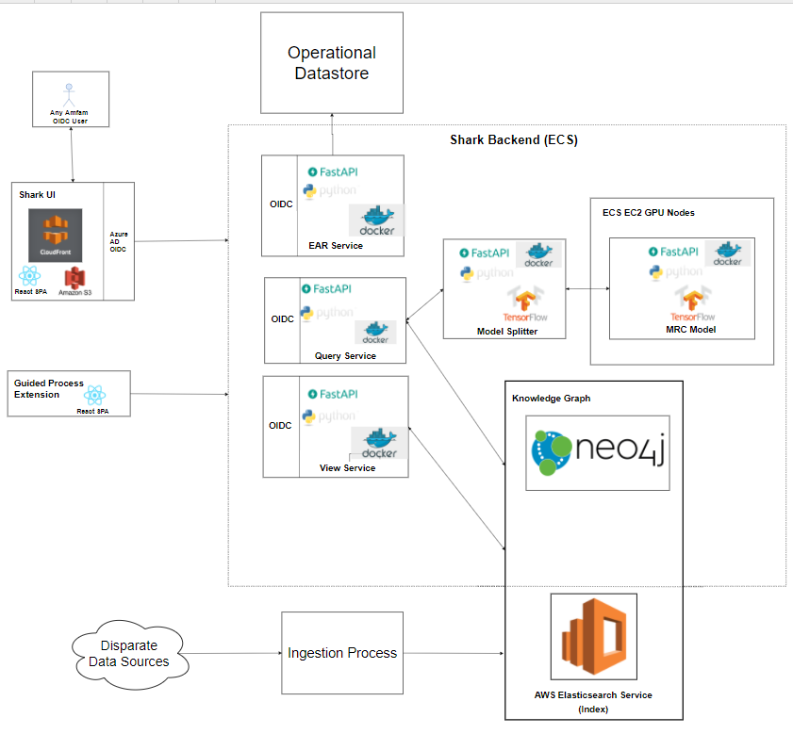

SHARK:

At its core, SHARK is a NoSQL graph database with a rich, high-level API that enables quickly iterating on ingesting new content and building application backends.

Every object in the SHARK database (the ARK) maps to a Python object, which can be manipulated in anyway a normal Python object could. Most importantly, this lets us leverage great Python libraries for AI, natural language processing and machine learning.

The graph structure stores arbitrarily complex data structures and captures any number of complicated relationships, processes, and hierarchies.

SHARKUI : The shark UI is the front end API which is accessed by the end user in order to search for the related content(works as wiki page).

The SHARK API fetches the information from the Operational Datastore which is divided into

* EAR Service: Auditing and logging information
* Query Service: The shark interface fetches the information from the query service
* View Service:

The shark UI interface is build on the NLP model which are run under the Tensorflow.

The backed information is maintained in Elasticsearch in AWS and all operational data service fetch the information through Elasticsearch and provide it to the user through a realtime NLP model.

SHARK INGESTION PROCESS:

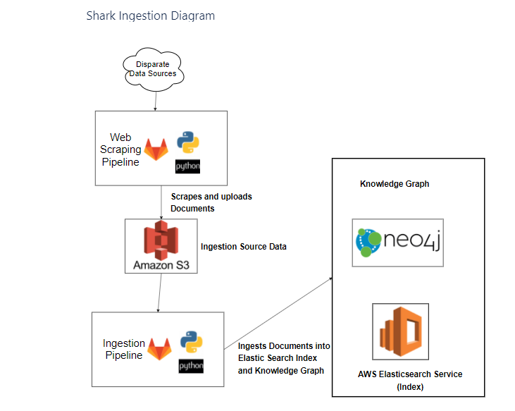

The ingestion process which loads the data in the Elasticsearch is done through the Web Scrapping. The web scrapping script download the on to the S3 bucket and through Python ETL process is loaded on the AWS Elasticsearch.

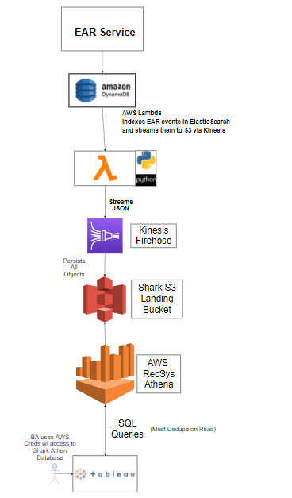

Operational Data Store:

To persist system, feedback for model retraining and operational data sources we setup a pipeline to persist data from EAR service into Athena. Athena feeds our operational dashboard and gives us the ability to query the data via SQL.

Shark Health Check-up

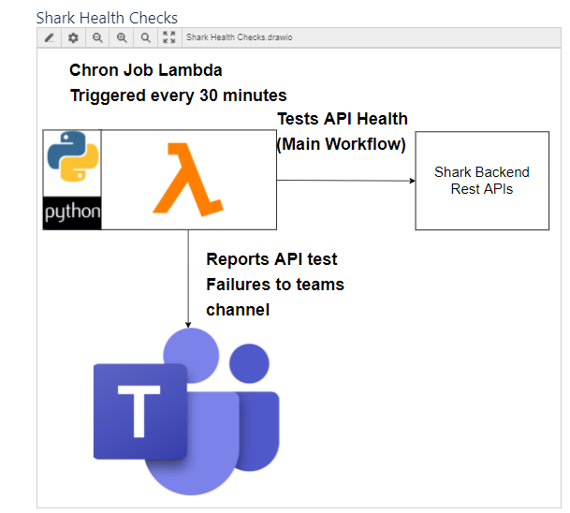

The Chron job lambda is triggered every 30 mins to the health of frontend and backend API system and notifies the users if there is any failure through the Microsoft teams communication channel.